**⭕Step1)Create a database server using AWS RDS & select MYSQL(5.7.30) DB type.**

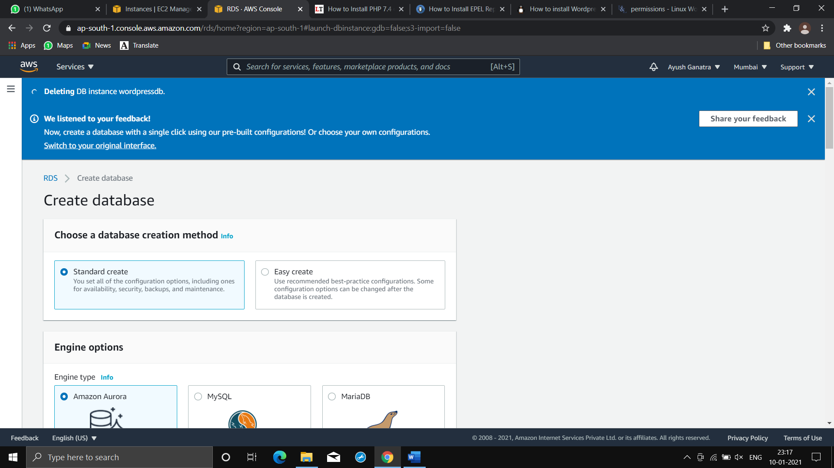

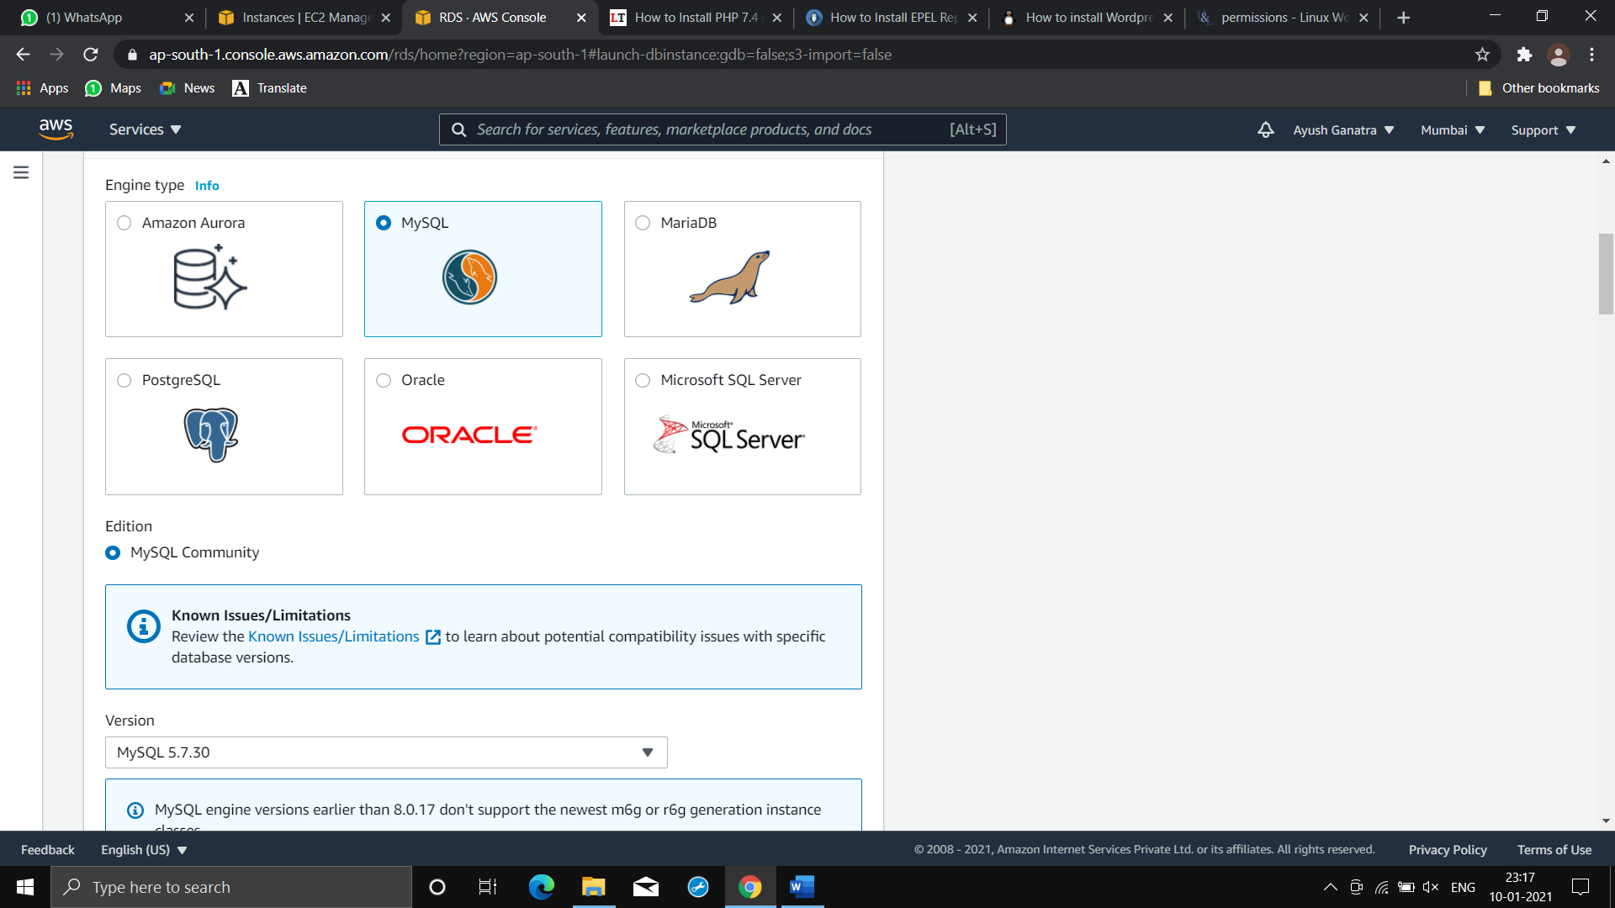

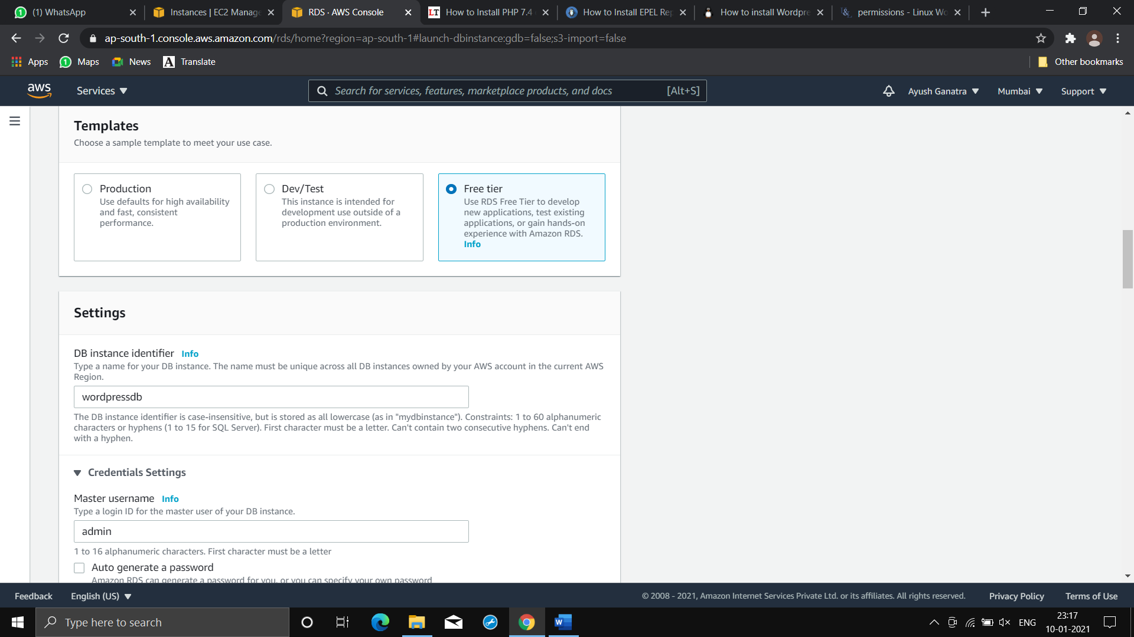

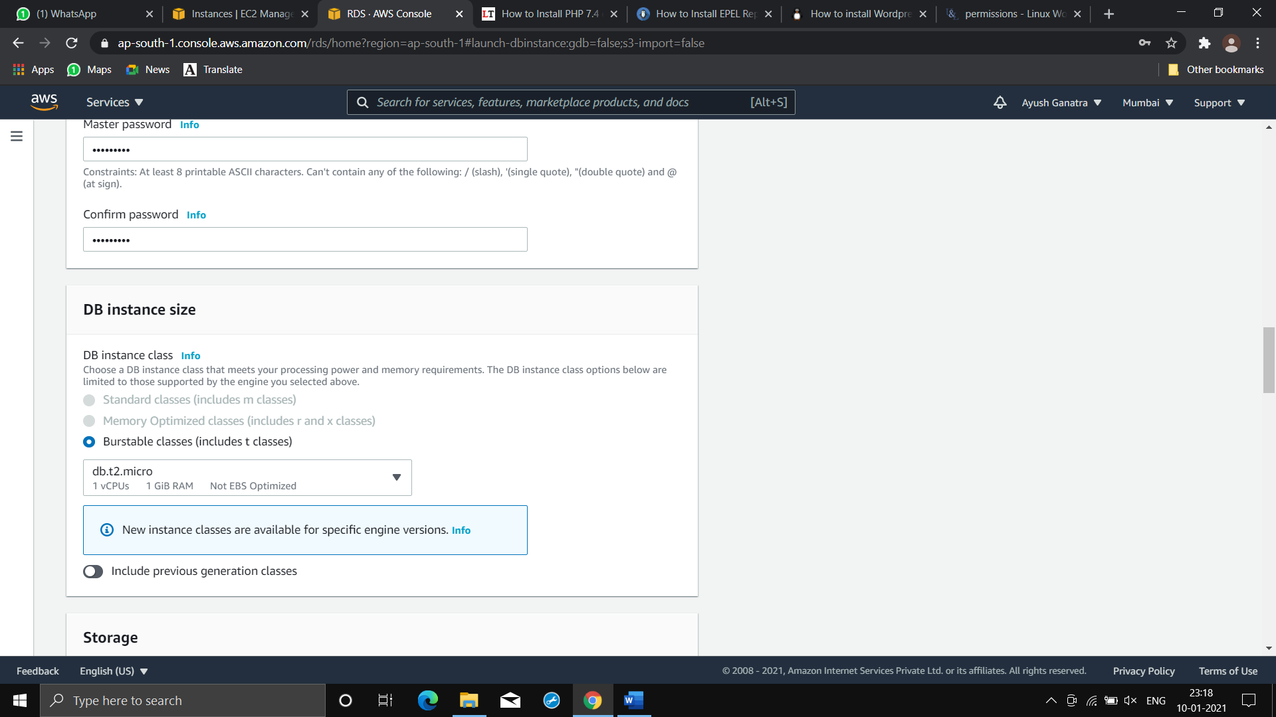

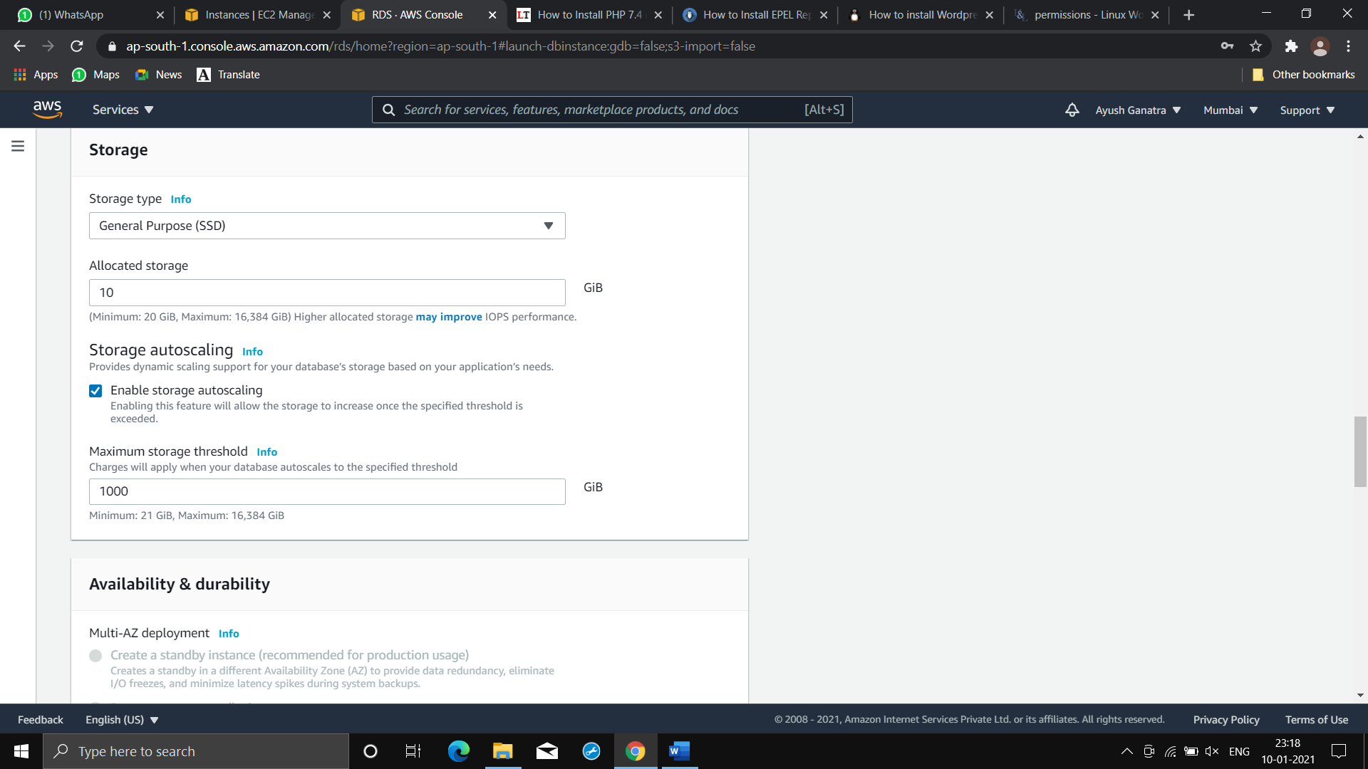

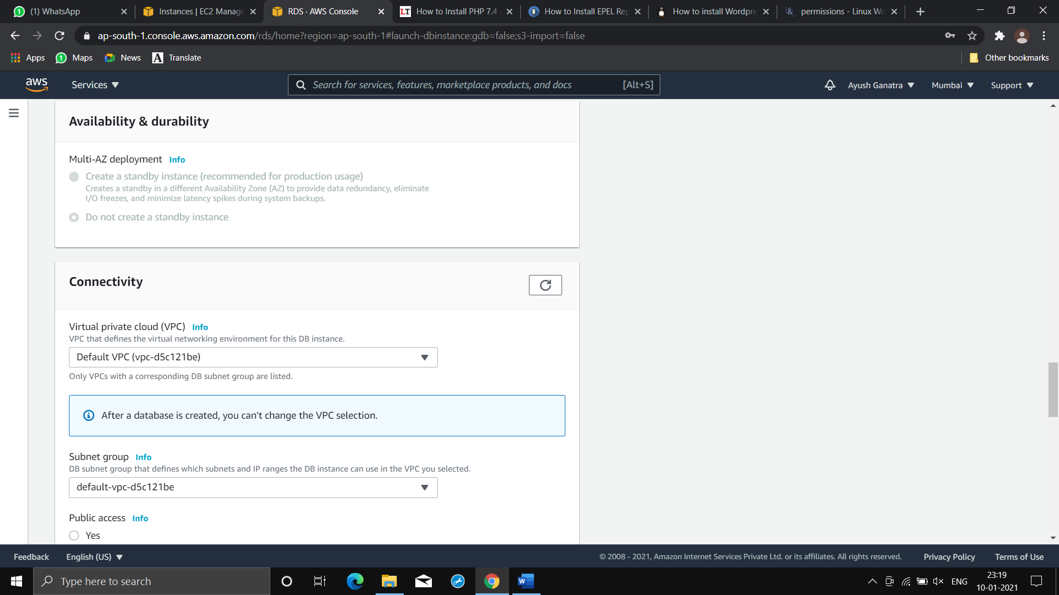

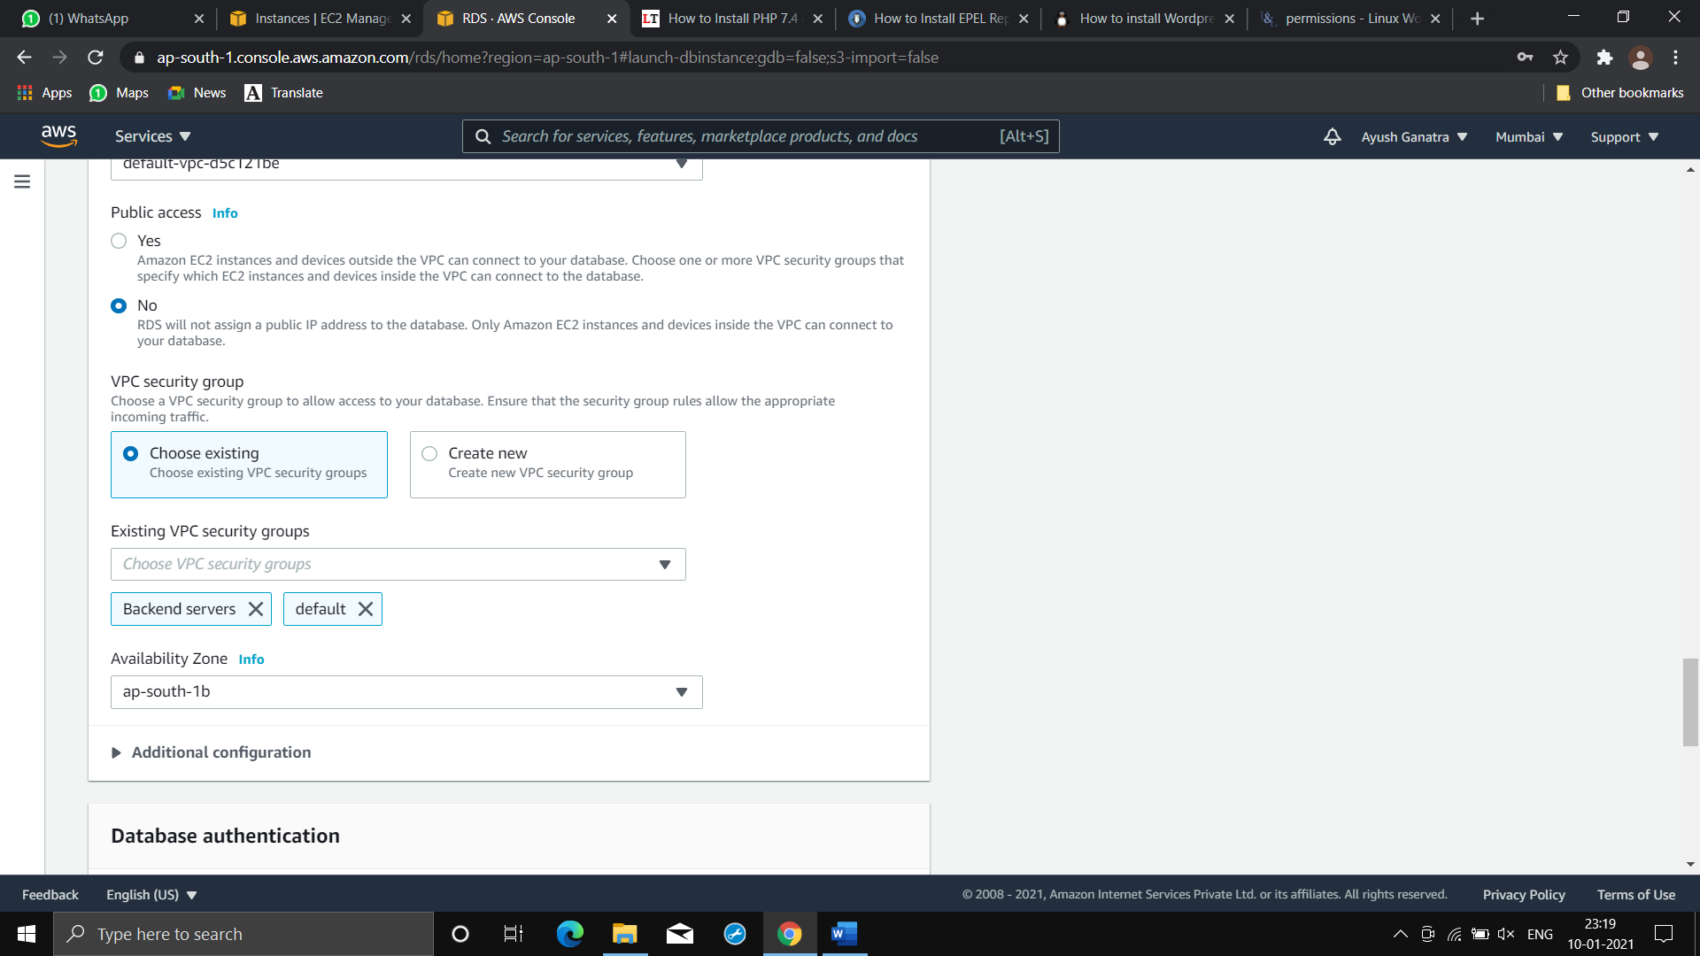

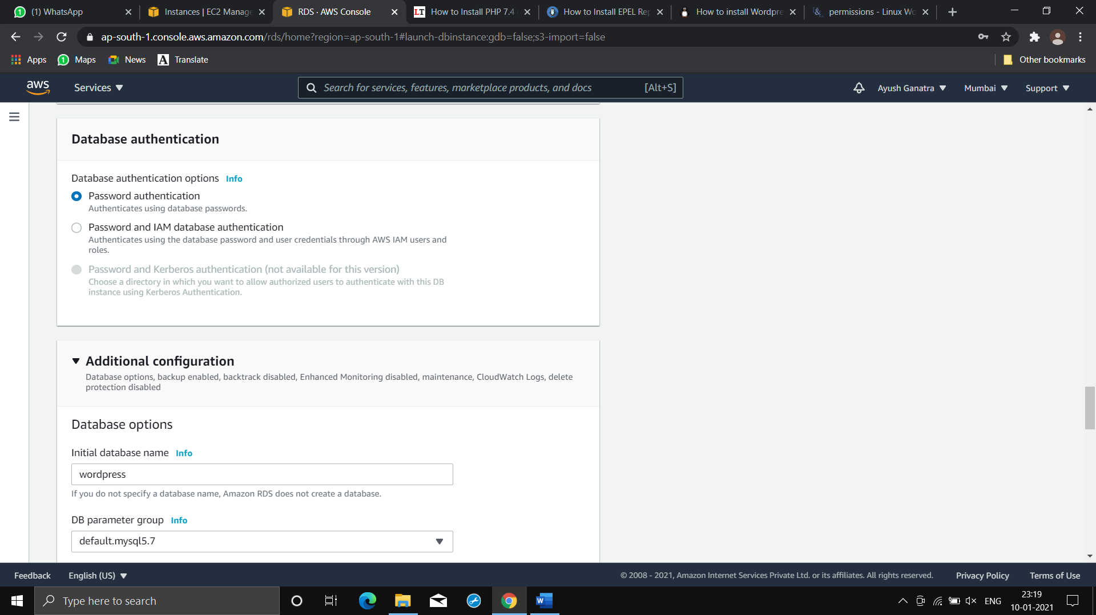

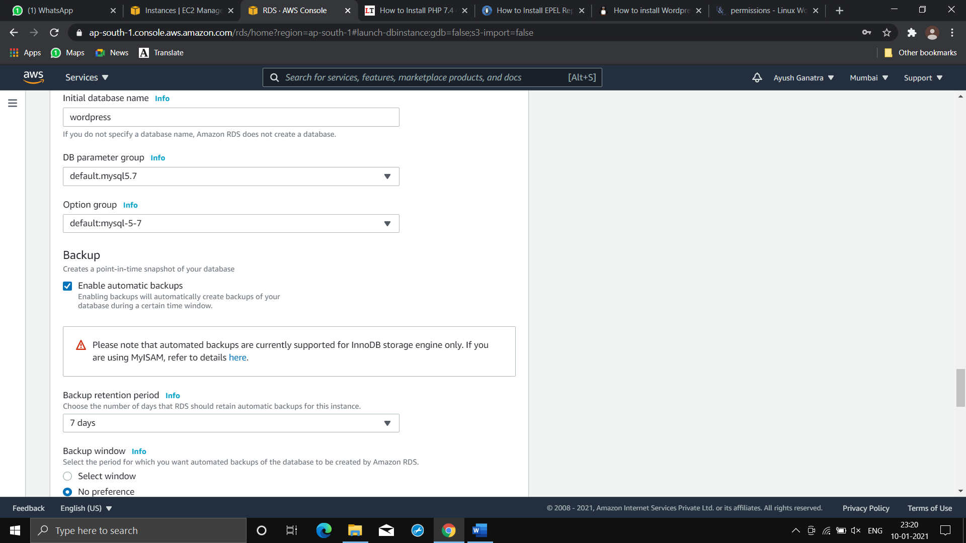

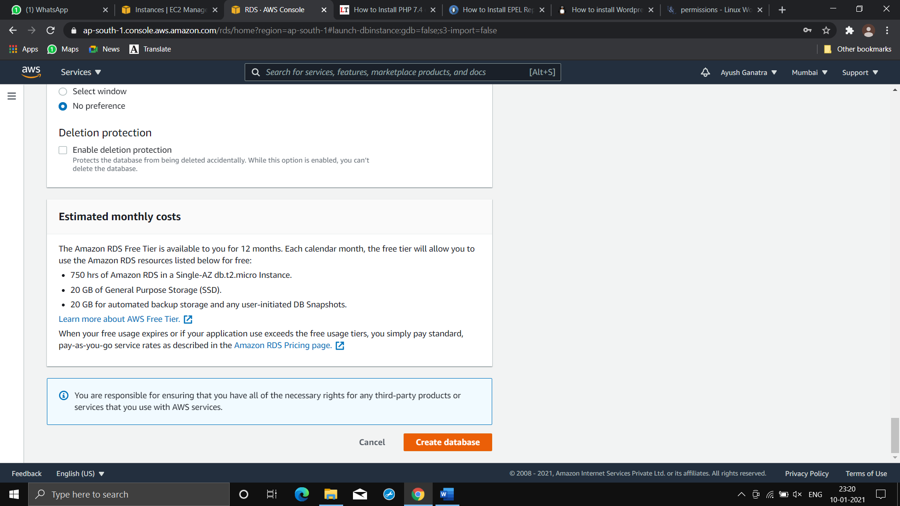

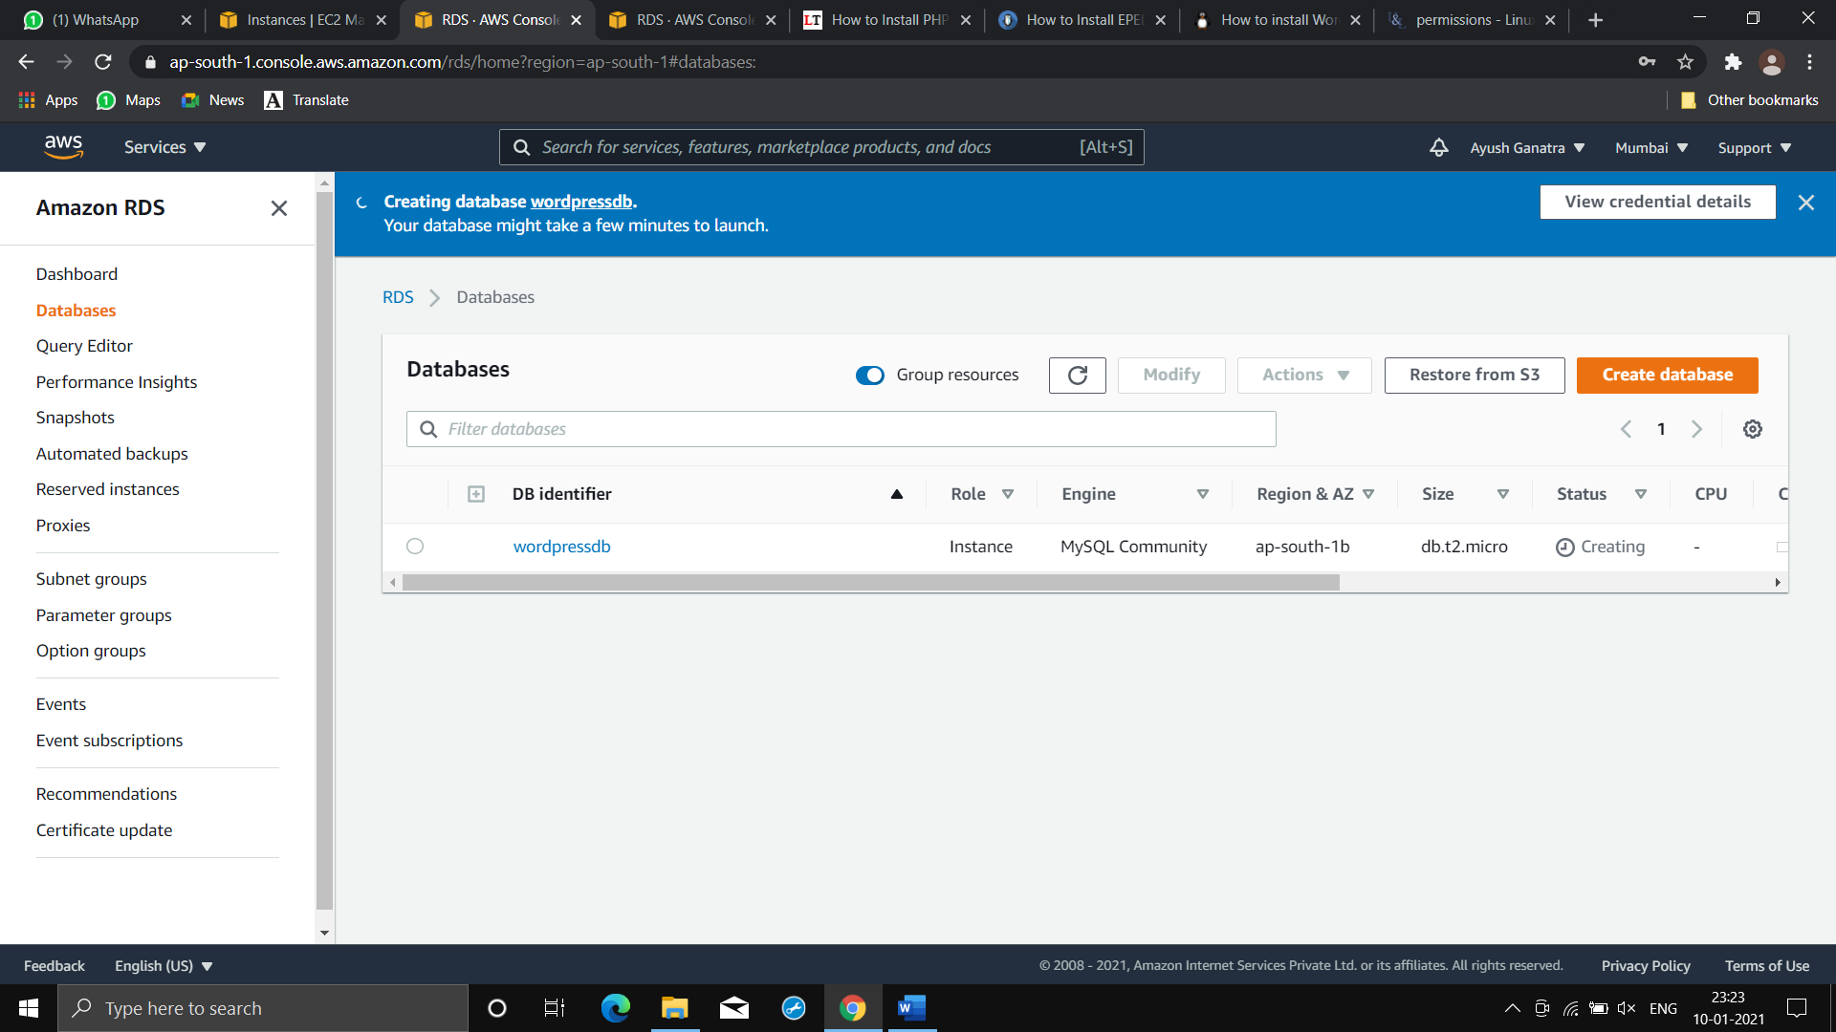

**⭕Our DB server has been launched!!!**

**⭕Step2)Launch AWS instance on which we will be installing wordpress application.**

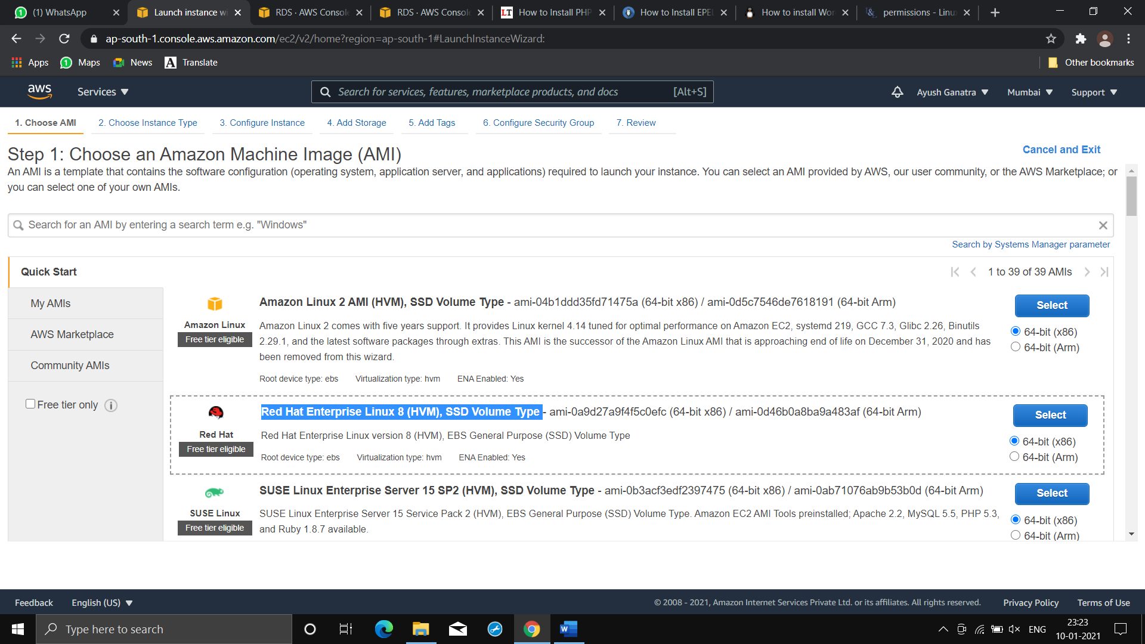

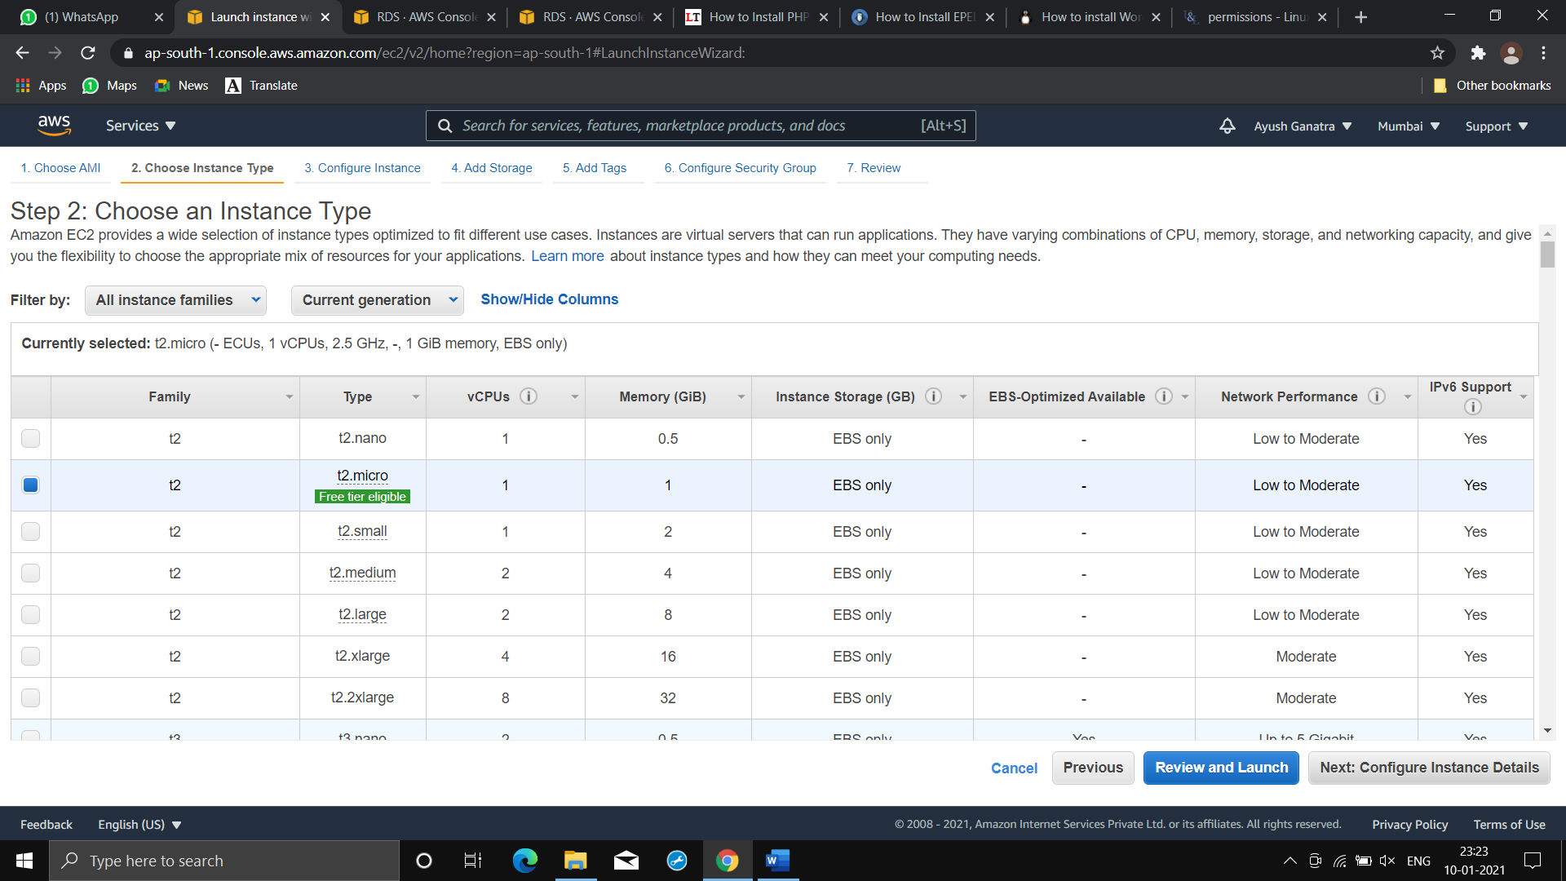

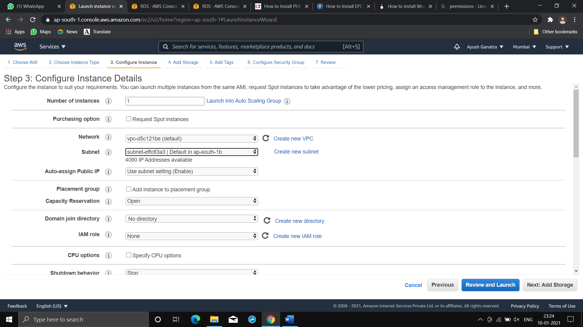

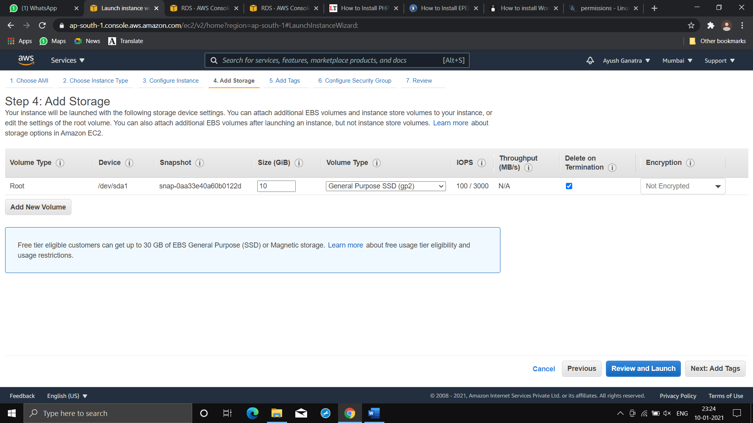

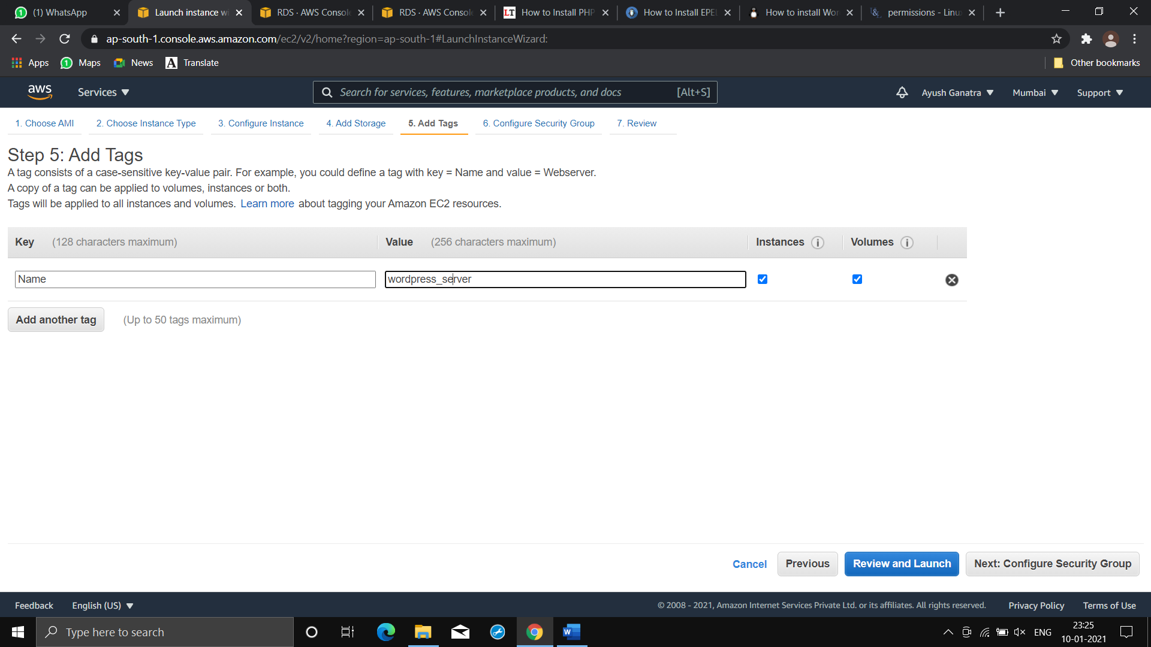

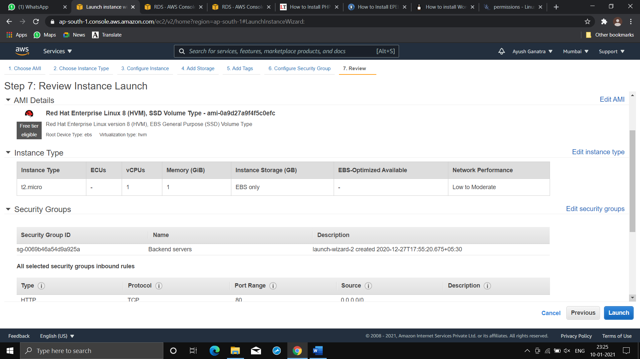

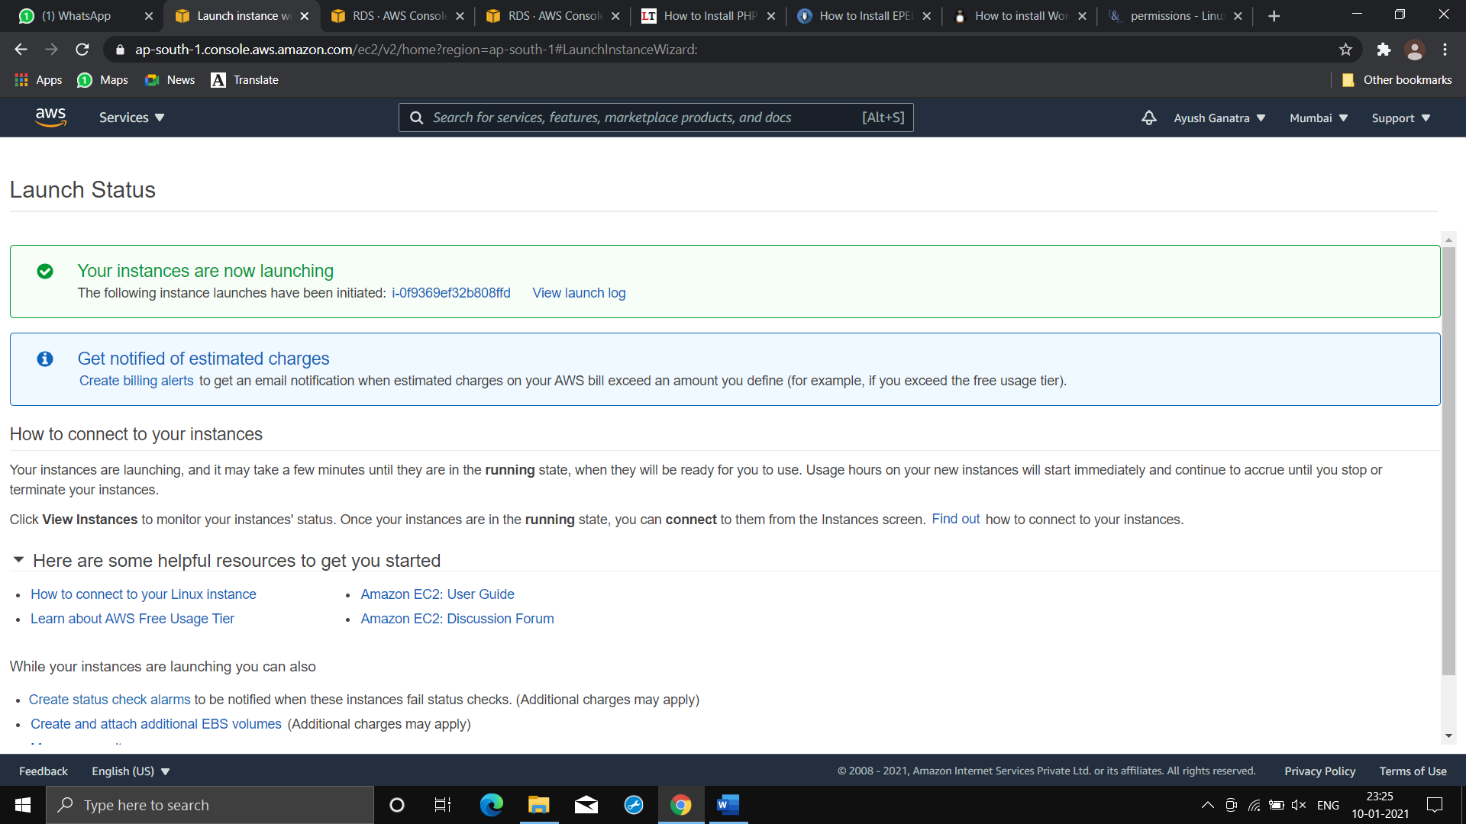

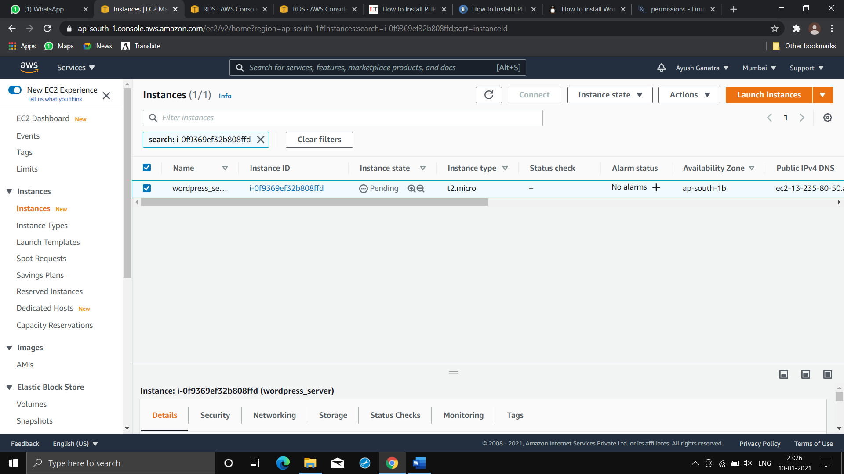

**⭕Our AWS instance has been launched!!!**

**⭕Step3)Install wordpress application in AWS instance.**

**⭕For this first we need to configure yum repos.**

**Cmd:**

dnf install https://dl.fedoraproject.org/pub/epel/epel-release-latest-8.noarch.rpm

**(For epel-release)**

**Cmd:**

sudo dnf install https://rpms.remirepo.net/enterprise/remi-release-8.rpm -y

**(For php)**

**⭕Now install software required by wordpress i.e. php-mysqlnd,php-fpm,httpd,php-jason,curl & tar.**

**⭕Now install wordpress from official site using curl cmd.**

**Cmd:**

**“curl https://wordpress.org/latest.tar.gz --output wordpress.tar.gz”**

**(It will download all wordpress files in tar archived form)**

**For extracting file use**

**Cmd:**

**“tar xf wordpress.tar.gz”**

**⭕Now copy wordpress folder to document root.**

**Cmd:**

**“cp -r wordpress /var/www/html”**

**⭕Then start httpd services**

**Cmd:**

**“systemctl start httpd”**

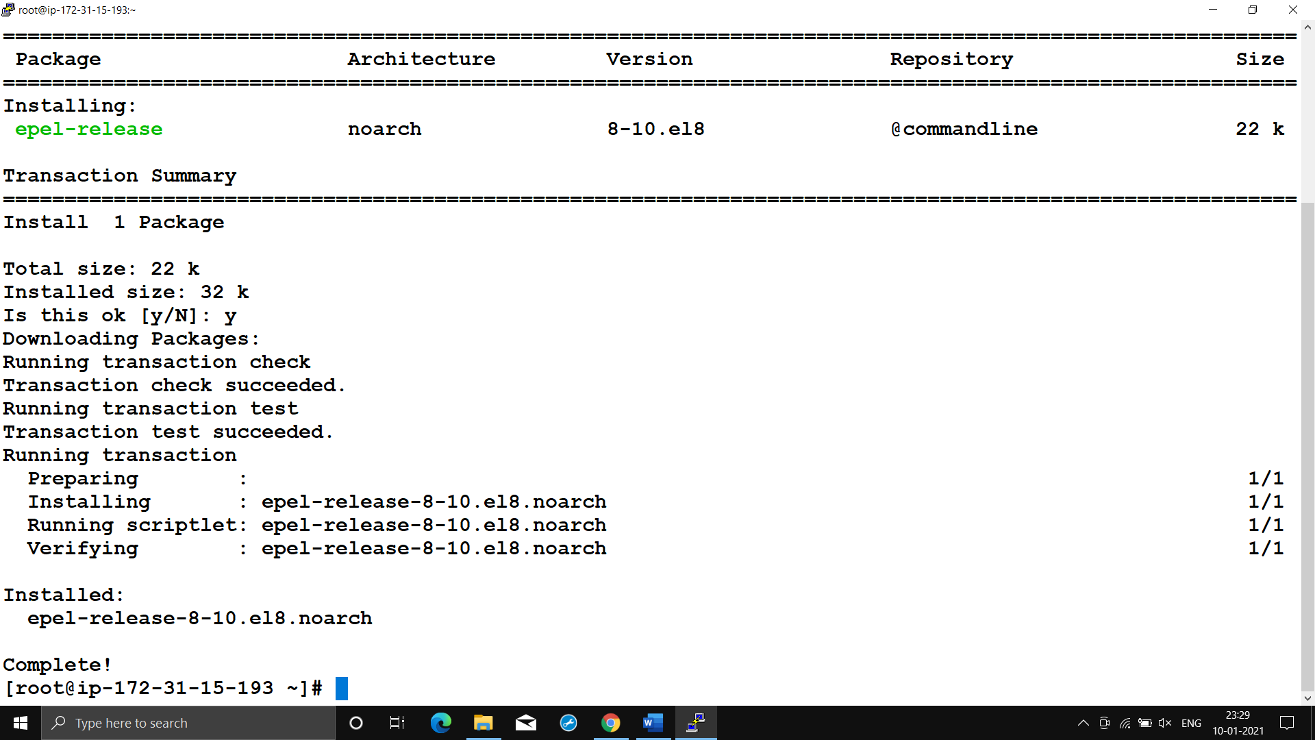

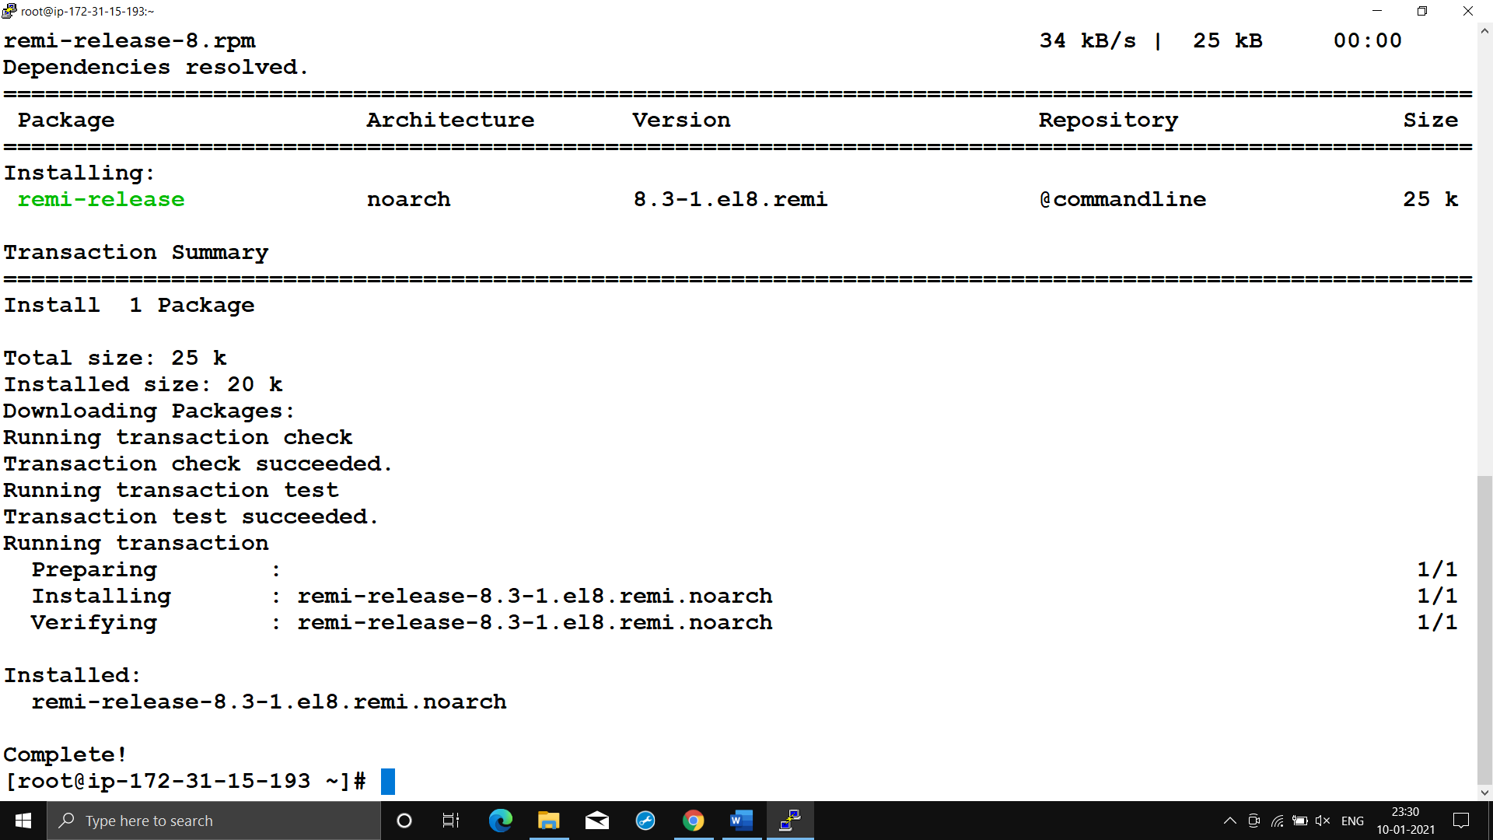

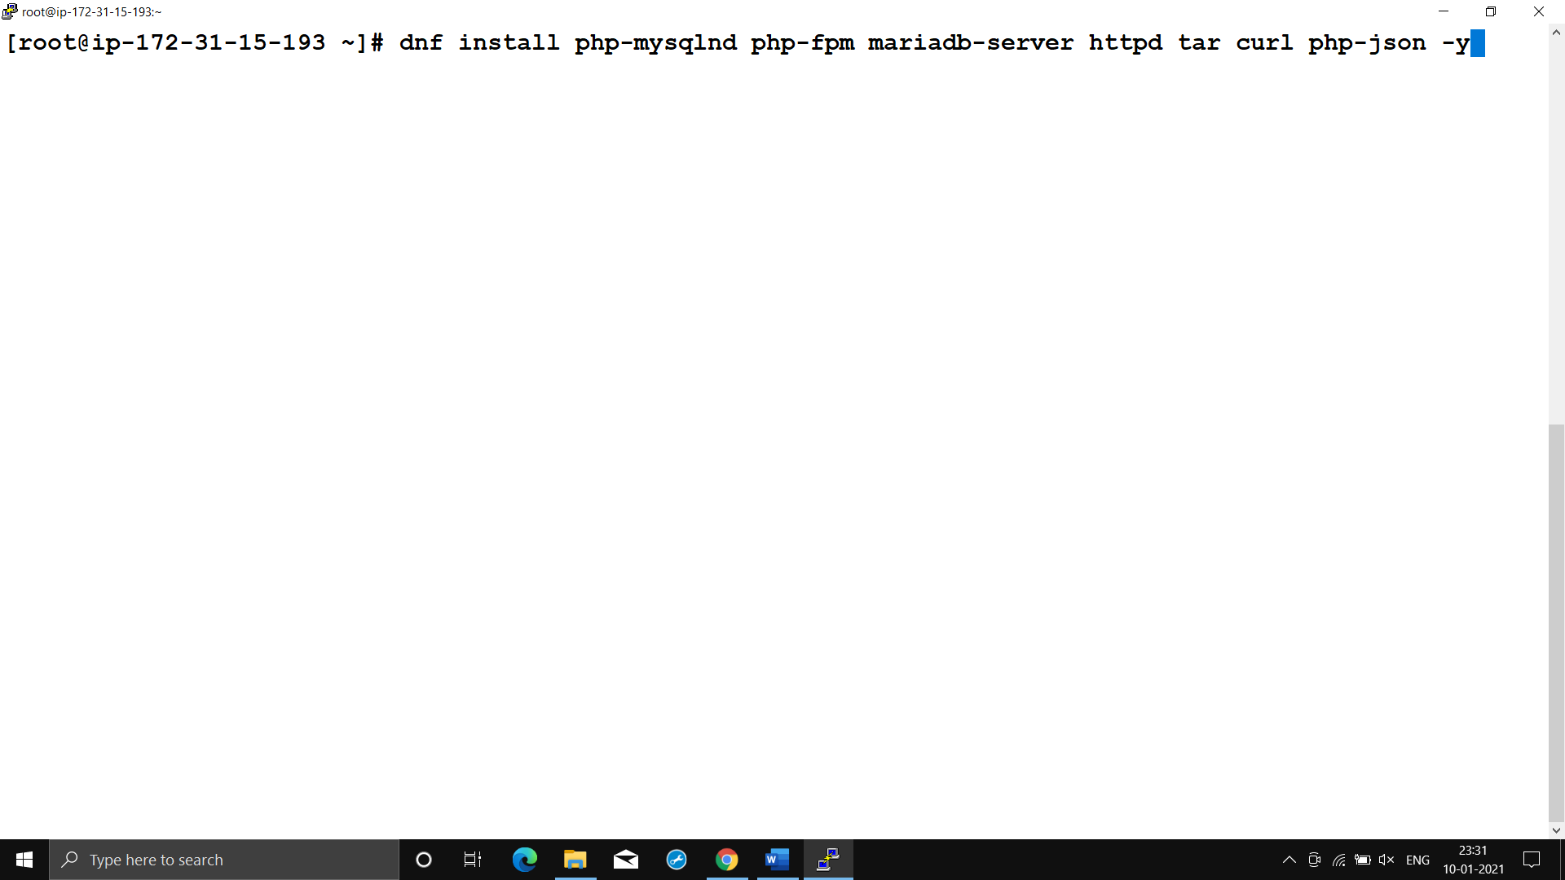

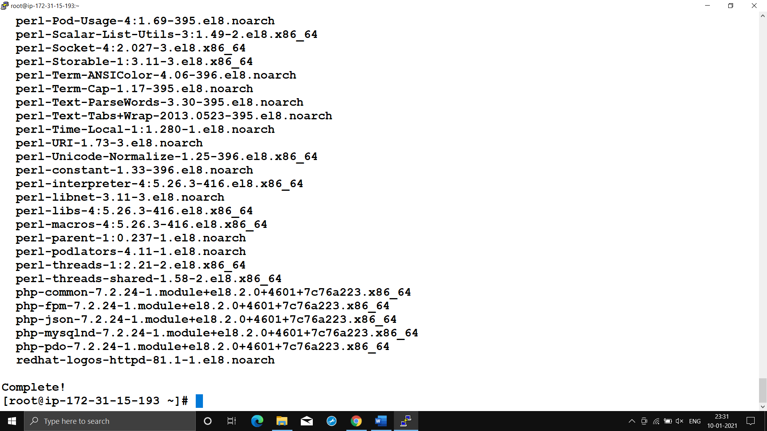

**⭕Here we can see that our DB server is ready for use!!!**

**& we can use end point for accessing the DB.**

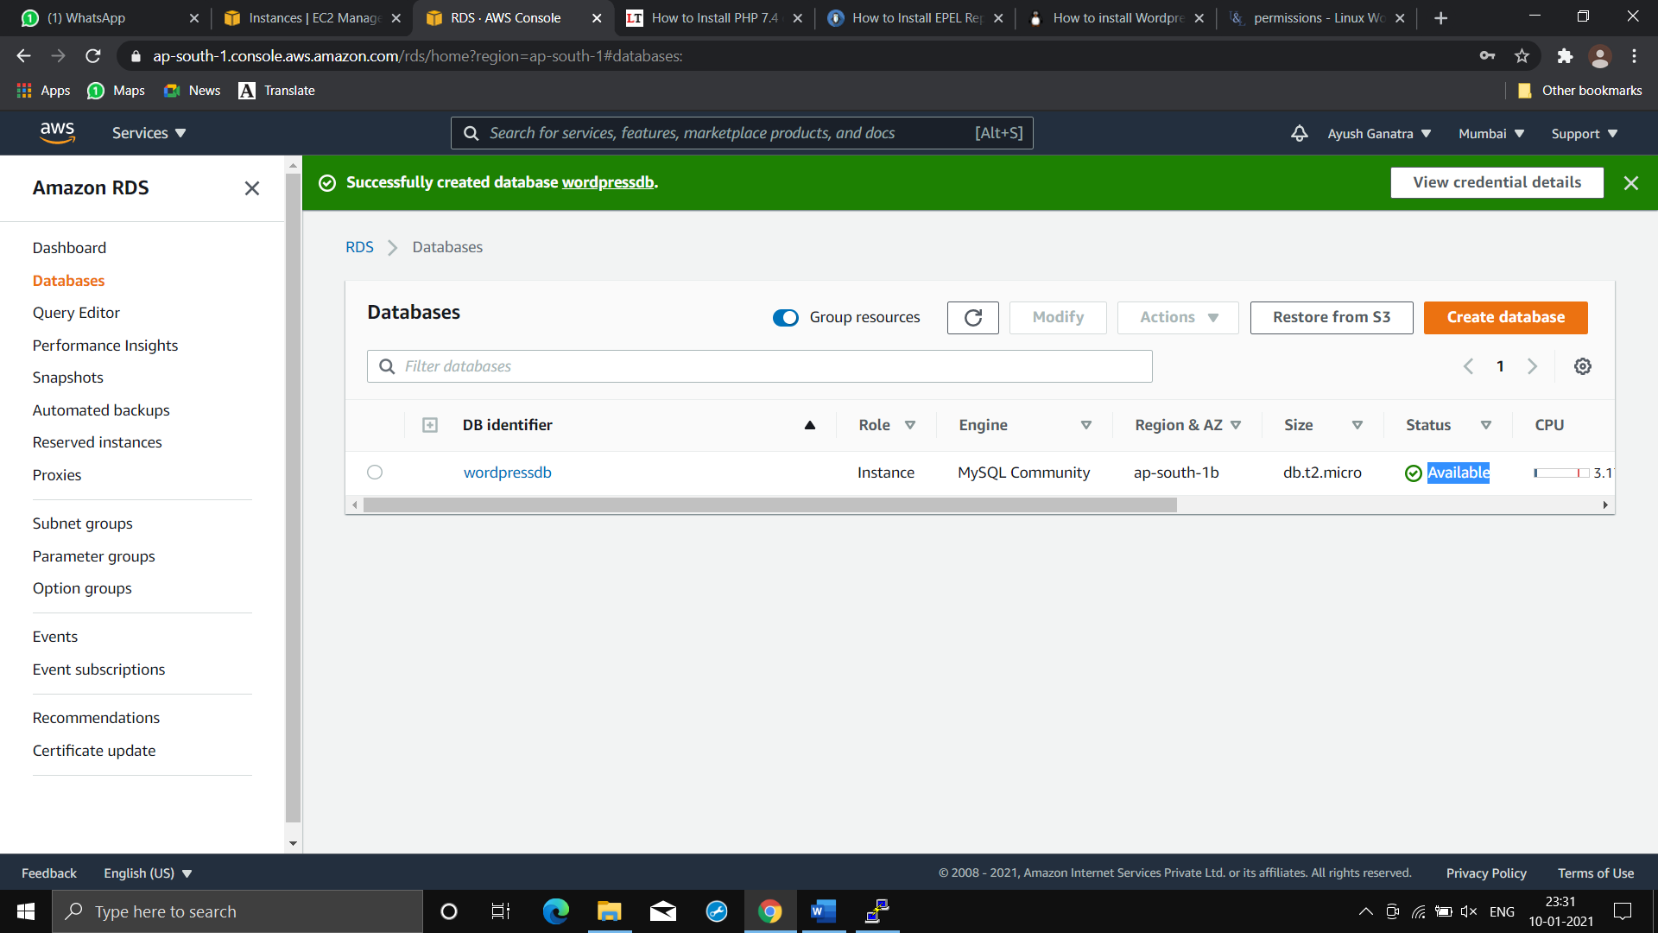

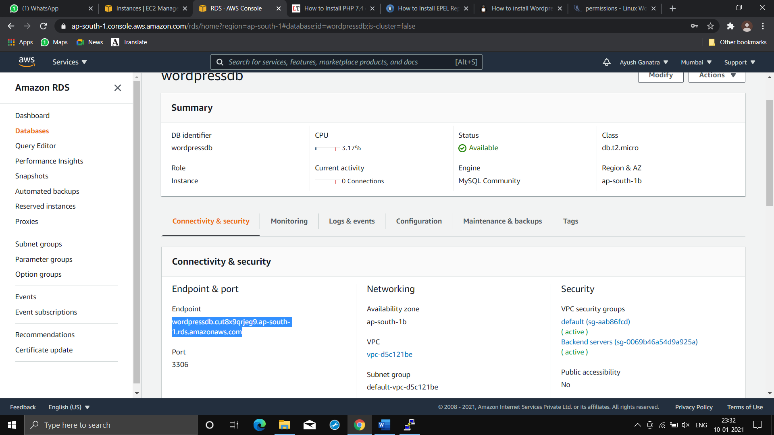

**⭕At time of DB server creation in advance option we gave instruction of creating initial database named “wordpress”!!**

**⭕So by connecting to DB server using endpoint we can see that “wordpress” DB is created!!!**

**For connecting use mysql cmd (-h : for using endpoint**

**-u : for specifying user**

**-p : for asking password)**

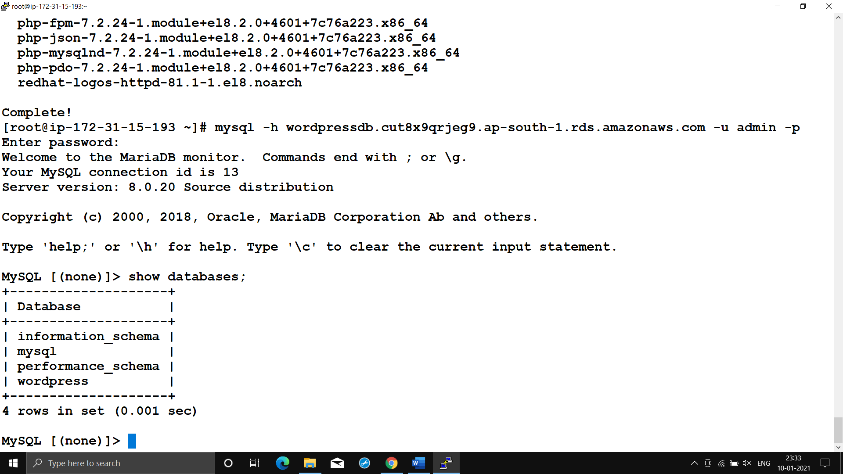

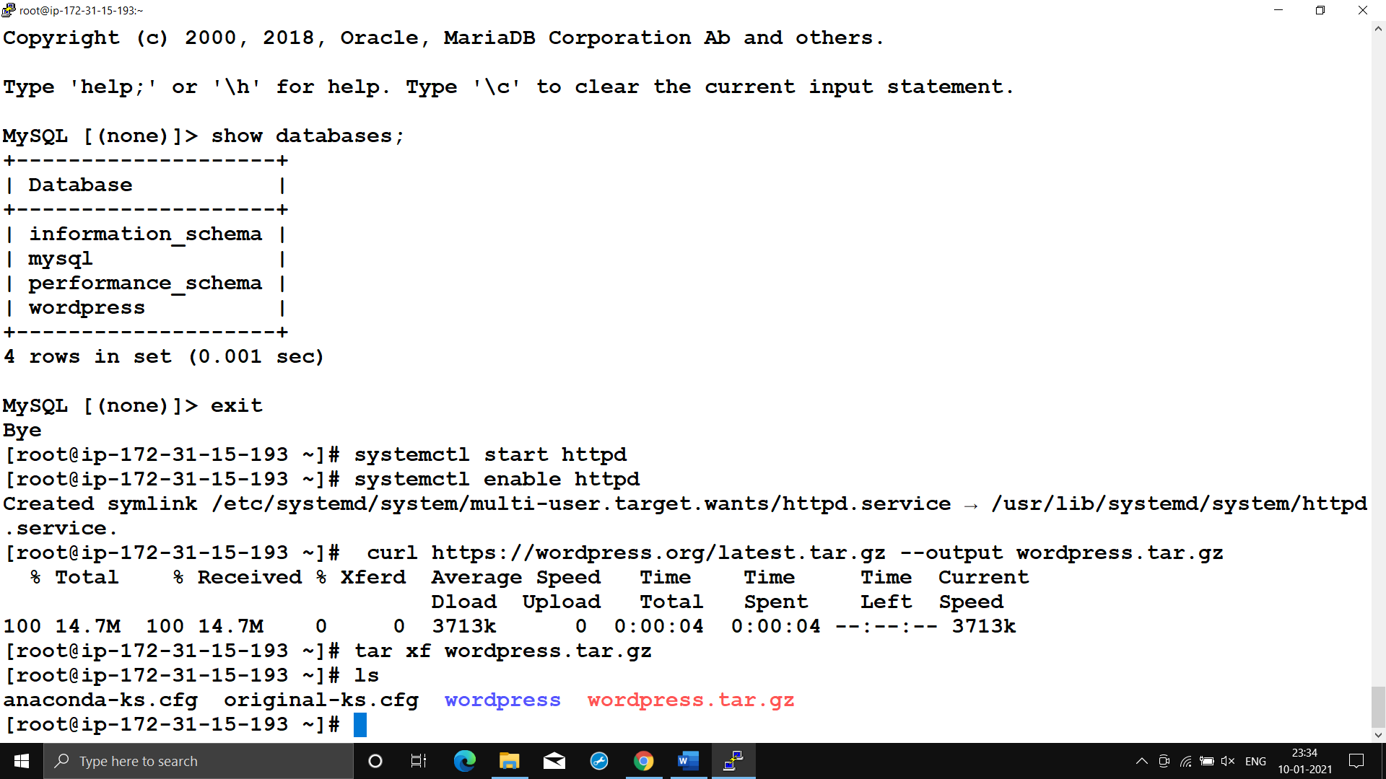

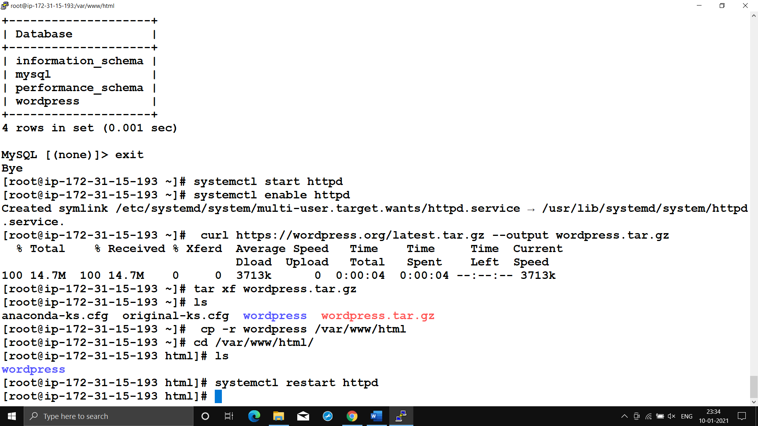

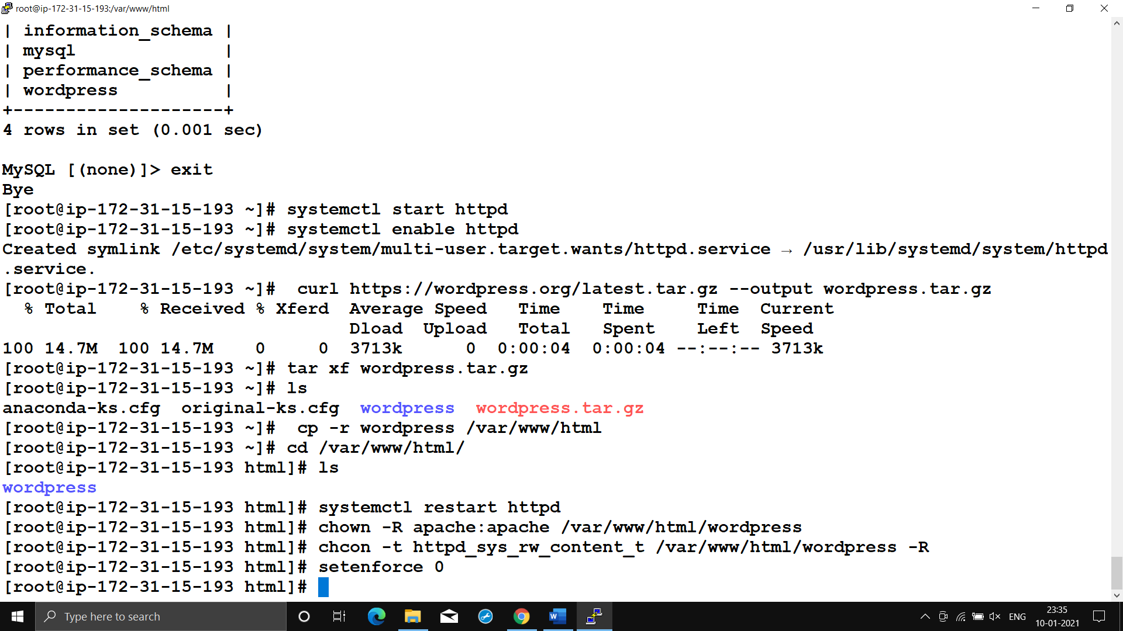

**Even after changing permission of folder I was facing problems due to SELinux hence I disable it & after it my set up was running successfully**

**Step4)Now we can proceed towards installation of wordpress**

**⭕Here we need to give name, password & DB user of DB created in DB server i.e. “wordpress” which is supposed to used by wordpress application.**

**Also we need to give location(endpoint of DB server in our case) of our DB server i.e. it can be localhost or as in our case it is located on AWS.**

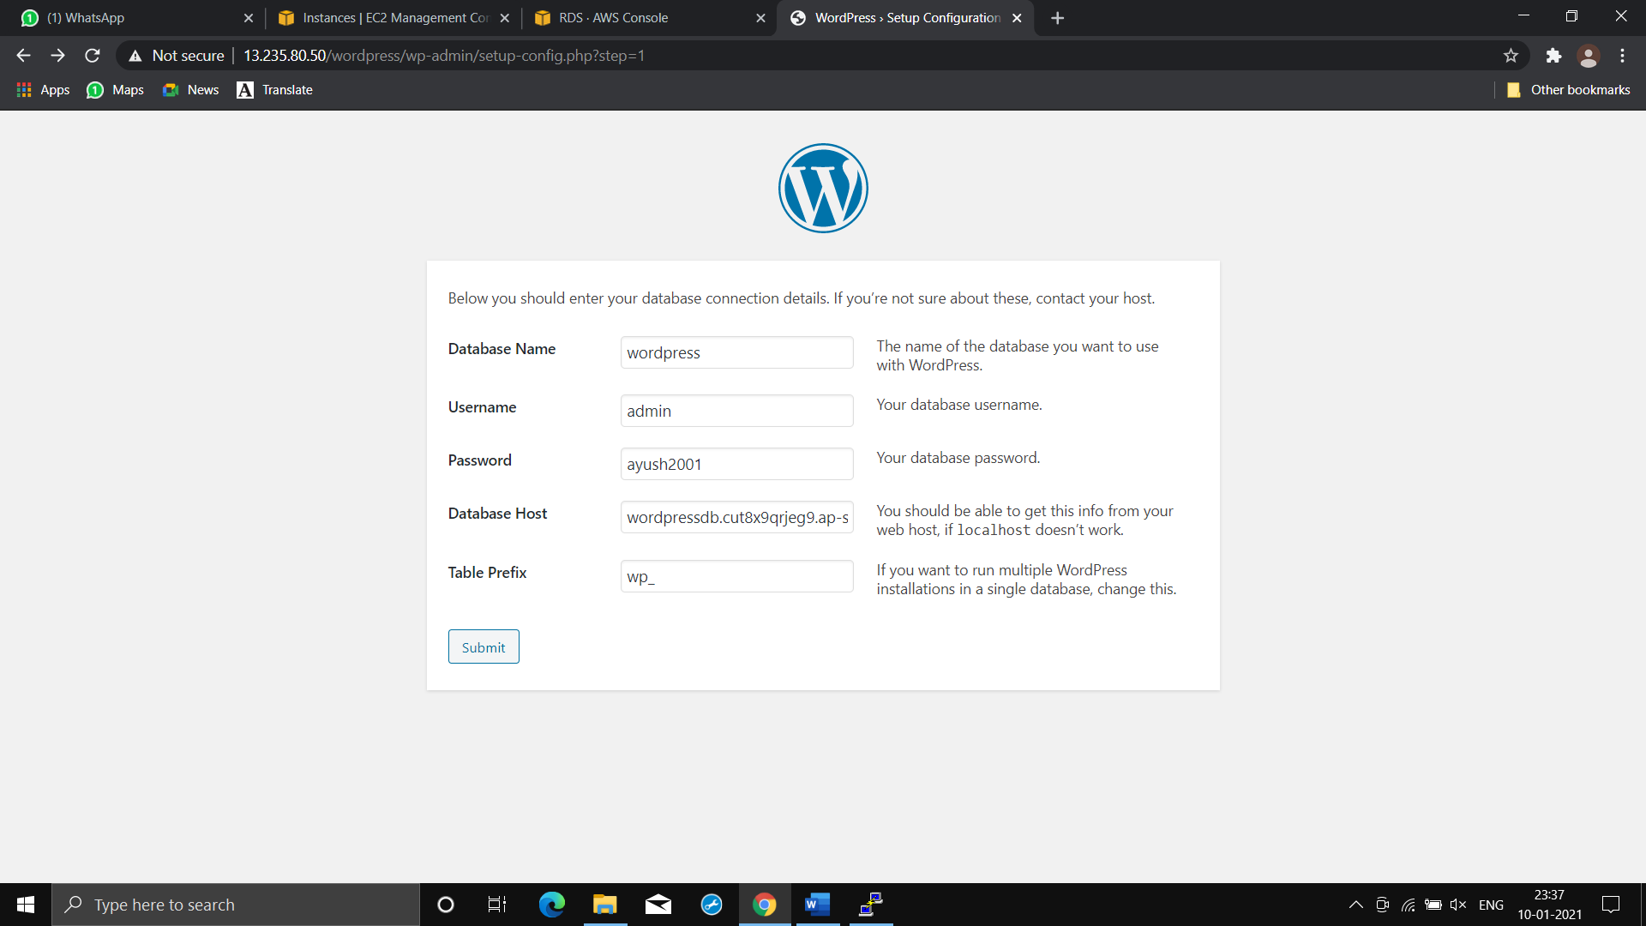

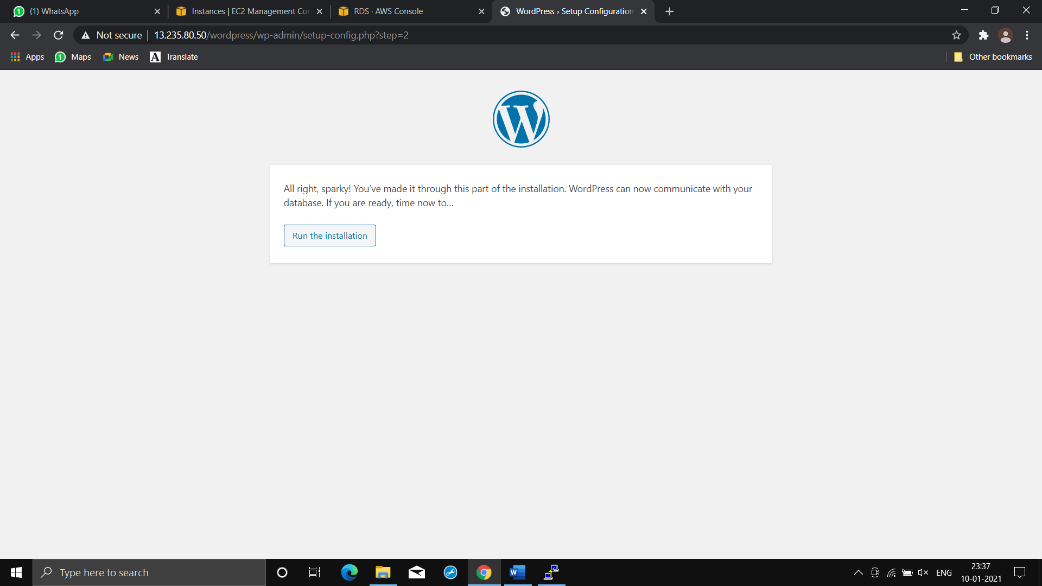

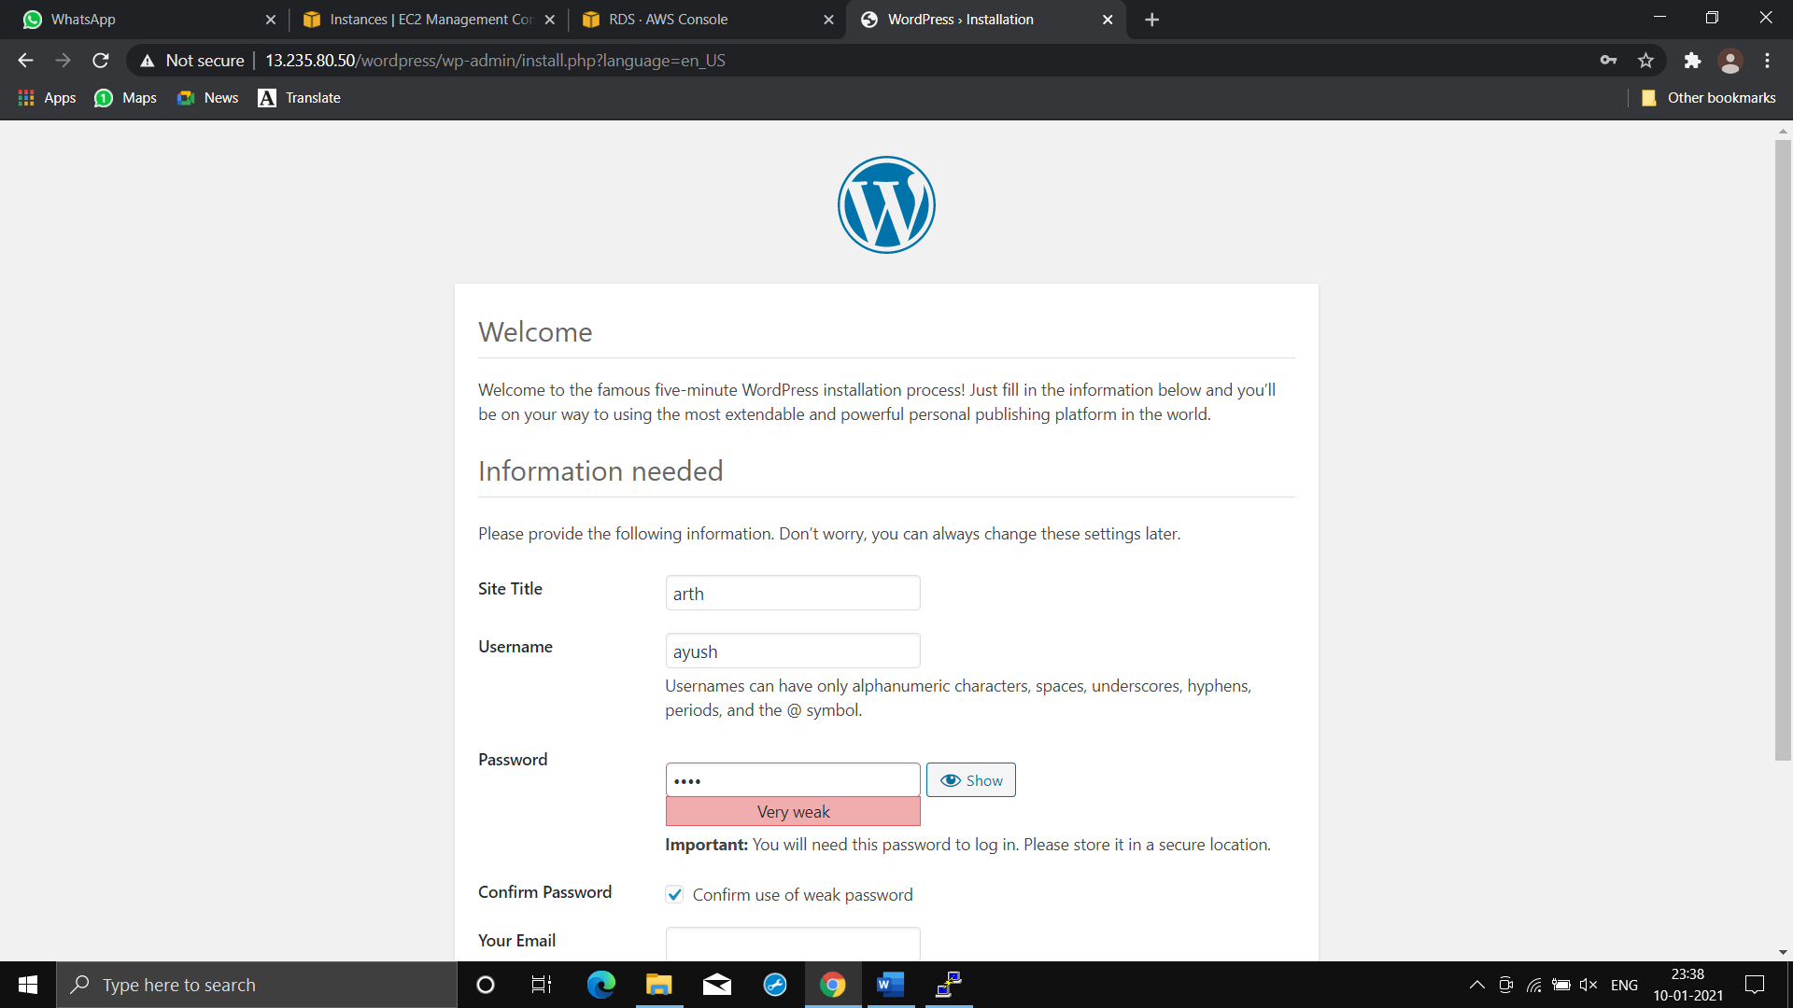

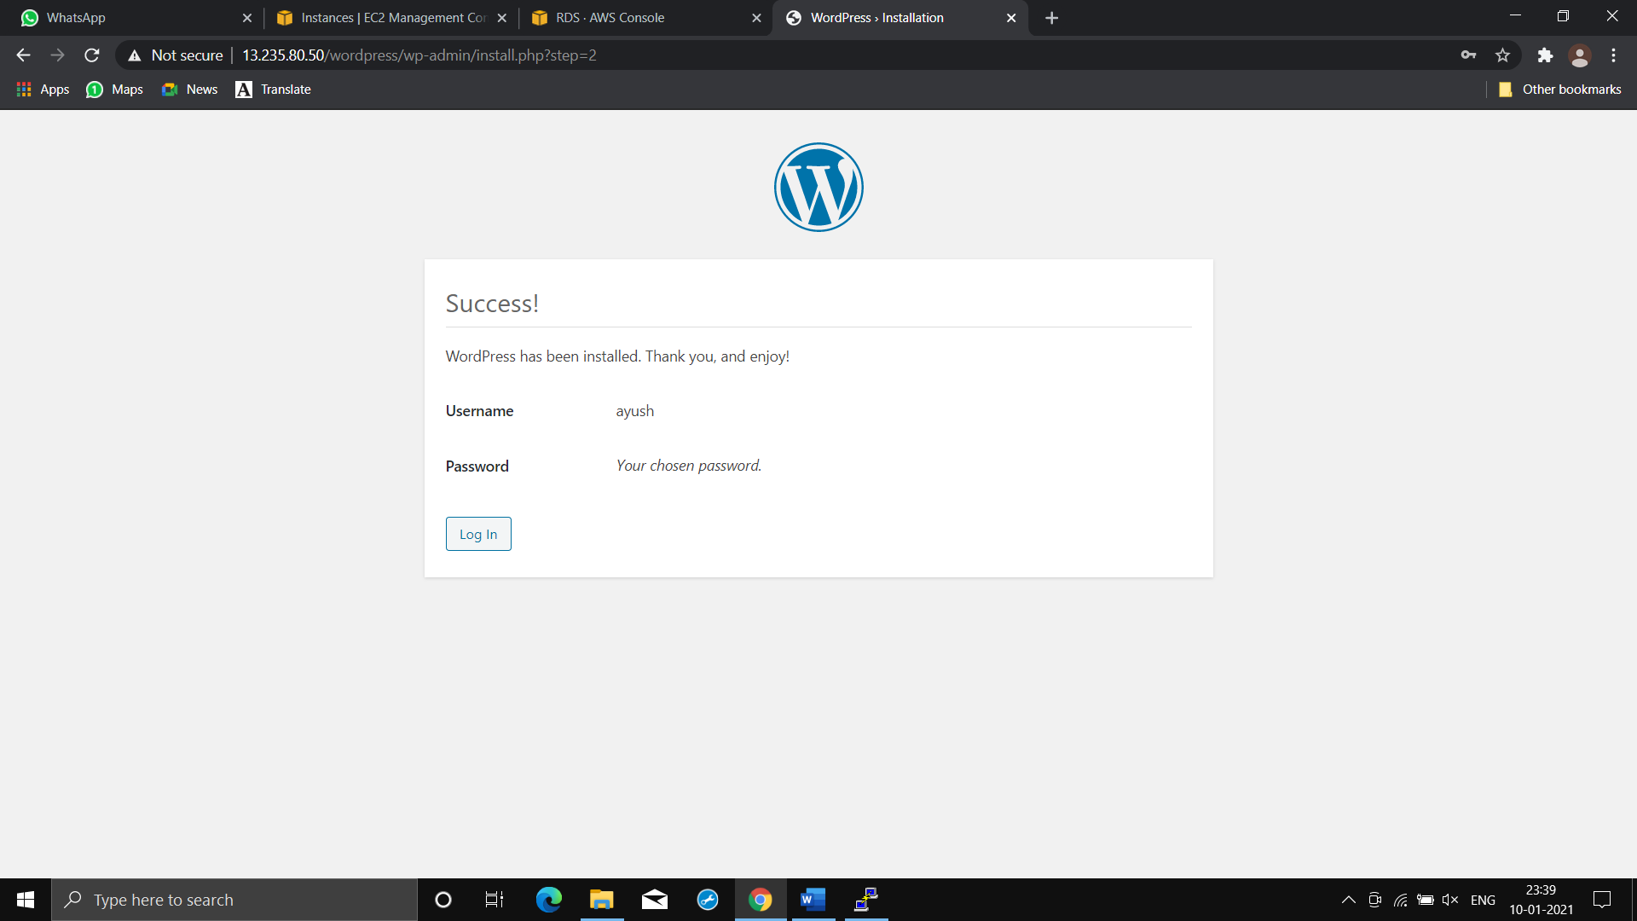

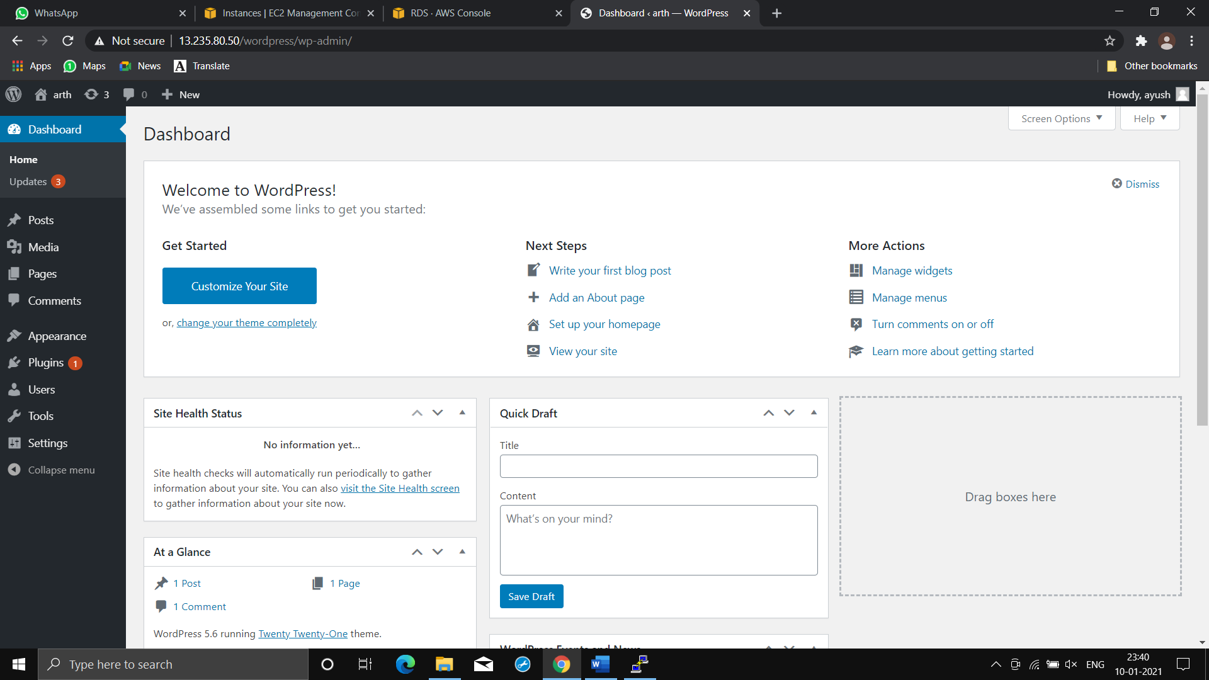

**THANKYOU FOR READING 😊**